## Study area

We sampled crab assemblages, eelgrass biometrics, and sea otter density along the west coast of Prince of Wales Island and nearby islands in Alaska, with sites ranging 93 km from the most southern site in Dunbar Inlet up to the most northern site in Naukati Bay (Figure 1). Sites were sampled from April to August during 2017–2020. Sites were selected following methods described in Raymond et al. (2021), briefly summarized here. We used the ShoreZone database and site visits to identify coastline segments with 100 m of eelgrass habitat with no overlapping kelp canopy (Harper & Morris, 2014, National Oceanic and Atmospheric Administration, 2021). Crab abundance and size composition and sea otter density were quantified at 21 sites in 2017 and 2020, 22 sites in 2019, and 6 sites in 2018. Eelgrass biometrics were sampled at 21 sites in 2017, 6 sites in 2018, 19 sites in 2019, and 6 sites in 2020 (Figure 1).

*Sea otter density data*

We quantified the number of sea otters near our study sites in a 3.7 km radius area, an area selected to represent the home range of sea otter territory. Two replicate boat-based sea otter abundance surveys were conducted at least two weeks apart each year for each site by counting all adult and independent juvenile sea otters in the area over water along a radius of 3.7 km from the site where crab pots were set (Figure 2). The exact survey area differed for each site given the complexity of the coastline. The presence and number of pups were not recorded. Sea otter counts were converted to density (sea otters/km2) based on the total area surveyed. Density was averaged between the two surveys per site per year.

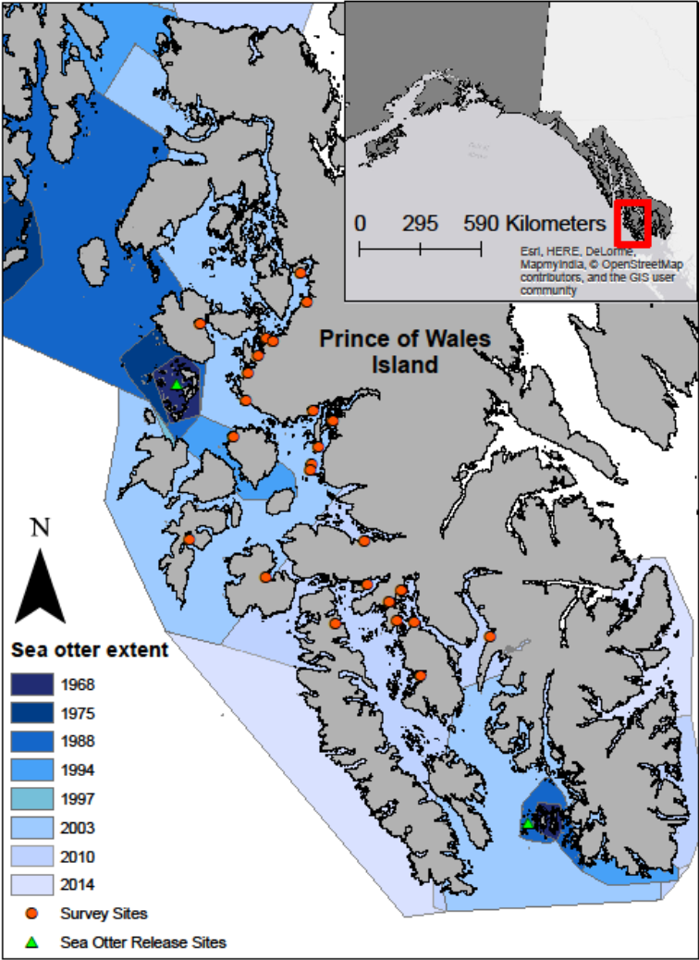

Figure 1 – Study area in Southeast Alaska near Prince of Wales Island. Orange circles indicate sample sites, green triangles indicate sea otter reintroduction sites, and sea otter colonization through time is color coded by year (blue).

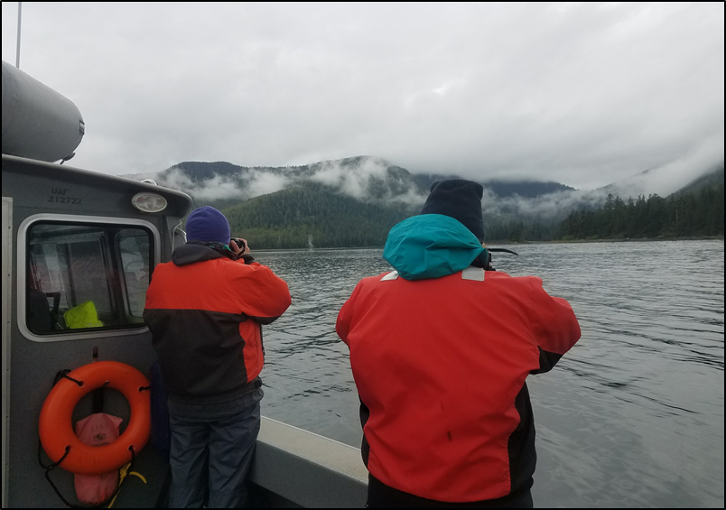

Figure 2 – A boat-based sea otter abundance survey conducted in 2019. Adult and independent juvenile sea otters were counted in the area over water along a radius of 3.7 km from the site where crab pots were set.

## Literature Cited

Harper JR, Morris M (2014) Alaska ShoreZone coastal habitat mapping protocol. Nuka Research and Planning Group, LLC.

National Oceanic and Atmospheric Administration (2021) ShoreZone.

Raymond WW, Hughes BB, Stephens TA, Mattson CR, Bolwerk AT, Eckert GL (2021) Testing the generality of sea otter-mediated trophic cascades in seagrass meadows. Oikos 130:725–738.